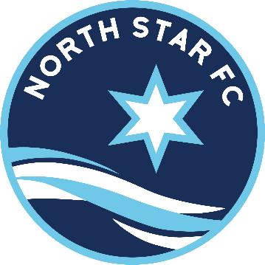
North Star FC Risk Management Policy

This policy provides requirements and guidelines for Player and Coach protection. All parents and coaches must ensure that the requirements are followed. In addition they are strongly encouraged to follow the recommendations listed here.
Definitions:

For the purpose of this document, an adult is defined as a person in the role of coach, assistant coach, team manager or volunteer who works with players. This may include an 18-year-old assistant coach on a U16 team.

A player is defined as a person who plays on a soccer team.
Requirements:
All people actively involved in working with the players must be registered with North Star FC.
This includes coaches, team managers, older sibling assistants, etc.
All registered adults must complete an MYSA background check and concussion training.
There must be at least one registered adult at all team activities.
In the case of a non-parent coach, there are additional responsibilities for the parents.
For the coach’s protection, a second adult must be present at all team activities.
Teams are not to place the player’s names on the back of the uniform shirts.
Any incidents of “suspicious strangers” loitering at a team’s practice must be reported to the North Star FC office. This is to coordinate reports of such activity at particular venues.
Sexual contact of any kind or type is prohibited between adults and players, whether or not contact is consensual.
Any “accidents” must be documented and reported to the Minnesota Rush office. This includes any situation where a player is taken for medical attention, even if this is not done immediately. For traveling teams, the team manager or coach must document this for the opponent’s team in the event a non-Rochester player was injured. This reporting is needed to ensure required information is available for any possible insurance claims filed at a later date. (This can sometimes occur years later.)
Any head injury resulting in disorientation of the player requires the player to remain out of that game.
Recommendations:
Parents and coaches are encouraged to talk to any non-team adults watching practices, etc. (Predators tend to get nervous and seek other prey when adults pay attention to them.)
Adults must be aware that any physical contact with players can be misinterpreted.
Physical contact should be limited to that necessary and appropriate to teach a skill, treat an injury, or console or congratulate a player. Adults must be careful to ensure they do not use contact which could be construed as placing them in a position of intimidation; i.e. physically moving a player into a position on the field by grabbing the back of their neck.
Transported players (other than their own children) should not be in the front seat.
*Remember:
Risk management is a second line of protection for children. As a parent, you must be the first line.

** To obtain a copy of MYSA’s Player Protection Program, visit the MYSA website at www.minnyouthsoccer.org (click on “Administration,” then “Risk Management”)

