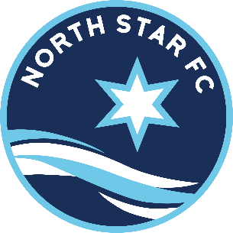
Participation Agreement
North Star FC Recreational League

As a participant in the North Star FC Rec League, I understand and agree to the following:
- I have read and will abide by all the rules and regulations of North Star FC.
- I have read and will abide by the North Star FC Risk Management Policy.
- I have read and will abide by the Rec League Code of Conduct and Expectations.
- I will treat my teammates, coaches, officials, and opponents with respect.
- I will not destroy or abuse North Star FC property or equipment. I will not hang on or pull on soccer goals or soccer goal netting and will discourage others from doing so.

- I will try to attend practices and games. If I will miss all or any part of a practice or game, I will notify my coach in advance. I will give advance notice of any extended absences because of family vacations, etc.

- I will try to be at games and practices on time. For practices, this means being at the practice field so that practice can start on time. For games, this means being present at the game field 15 minutes before game time unless otherwise directed by my coach.

- I understand that coaches and players will occupy one side of the field during games; parents and fans will occupy the opposite side of the field. It is the coaches’ discretion as to which side the teams will occupy.

- I will inform my coach of any injuries sustained while practicing or playing soccer.

- Whenever I play or practice soccer, I will wear shin guards with socks completely covering them, wear eyeglass straps with eye glasses, and take off jewelry and hair beads, bobby pins, etc. I will wear shoes appropriate to the playing surface. I will try to dress according to the weather while still being able to practice or play a game.

- I will bring a water bottle to practices and games and a ball to all practices.

As a parent or guardian, I have read through this agreement with the child and agree to set a good example and be supportive:

- We will exhibit and encourage good sportsmanship.

- We will be on time for getting to practices and games and on time for picking up our child from practices and games.

- If being on time is a problem, I will discuss this with my child’s coach.
No Smoking Allowed at North Star FC Games or Practice Fields.
_________________________________ ___ _____________________________________
Parent Signature Player Signature

__________________________ _____________________________________
Date Player Name (Print)

