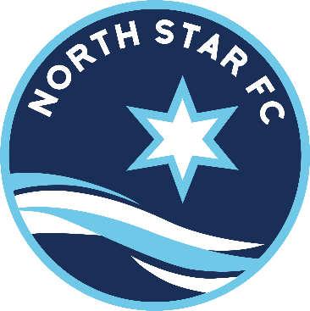

Code of Conduct
North Star FC Recreational League Code of Conduct and Expectations
for Players, Coaches and Fans

Introduction:
Soccer is a competitive sport, but the emphasis of the Rec league is on participation, development, and just plain fun. This obviously applies to the players but in many cases applies to the coaches, fans and referees as well, many of who are youth themselves or new to the game of soccer. The Rec league serves as a training ground for the future of soccer and it is essential that everyone have a positive experience. The Rec League Code of Conduct and Expectations describes expected behavior of players, coaches and fans whose observance will enhance the soccer experience for everyone.
Players:
Players are expected to exhibit good sportsmanship and behavior at all times to players, referees, coaches and fans of both teams. During the game, an active player may ask the referee to clarify. “What was called”, but may not question the referee on rule interpretations, argue or express dissent, either verbally or by action. The referee should be addressed as Sir or Ma’am with courtesy and respect. However, realize that circumstances may not allow an immediate response from the referee.
Coaches:
The coach sets the standard for acceptable behavior for both the players and the fans. A coach’s positive attitude and behavior toward their team, the opposing team and the referees promotes a positive experience for everyone. A negative attitude or behavior can discourage the young players and referees we are there for. Therefore, the coach is held to the highest standard of behavior.
The coach is responsible for managing the sidelines including the players, fans and equipment.
- For purpose of safety and vision, no person or equipment is permitted within 1 yard of the touch line. This area is reserved for the assistant referee in order to perform their duties.

- While coaching, the coach and assistants shall remain within the coaching area which extends 10 yards on either side of the center line. No coaching is permitted outside of this area.

- The coach is not permitted to argue or express dissent, either verbally or by action or enter the field of play unless signaled to do so by the referee.

- The coach should promote sportsmanship towards both teams and the referees and remember the developmental purpose of the Rec league.

  - For purpose of promoting positive experience for developing referees, the coach shall not dissent or express negative comments about the officiating to players, parents or the referees during or after the game. Realize that the referee cannot see everything on the field, that they are impartial and that they are doing their best.

  - No abuse or negative comments towards players of either team will be allowed. The coach should encourage sportsmanship and applaud good play from either team.

- The coach should not challenge or question a youth referee, either during or after the game. Questions may be addressed only to an adult referee or a field marshal in a calm quiet voice on questions of rule interpretation.

- The coach is to refrain from consuming alcohol, tobacco products, or illegal drugs prior to or during contact with players.

- North Star FC reserves the right to remove or suspend any coach for violation of the rules above.

Fans:

Fans should exhibit good sportsmanship and provide encouragement to players, referees, and coaches of both teams. Simply stated, if you don’t have something nice to say, then don’t say it. Dissent, either verbal or by action, or harassment of referees or players will result in expulsion from the field. Do not enter the field of play at any time. Do not encroach into the assistant referee area (1 yard along touch line). Do not stand behind the goal area. Refer all comments and questions to the coach. The use of tobacco, alcohol, and/or drugs is not permitted at any North Star FC game or practice area.

