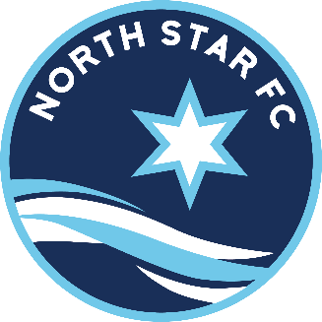
Coach Agreement
North Star FC Recreational League

As a coach in the North Star FC Rec League, I understand and agree to the following:
- I have read and will abide by all the rules and regulations of North Star FC.
- I have read and will abide by the North Star FC Risk Management Policy.
- I have read and will abide by the Rec League Code of Conduct and Expectations.
- I have registered with North Star FC.
- I have completed the MYSA background check, concussion training, and SafeSport training.
- I will not destroy or abuse North Star FC property or equipment.

- I will refrain from consuming alcohol, tobacco products, or illegal drugs prior to or during contact with players.

- I will treat my players, officials, and opponents with respect.
- I will ensure that each player on my team plays at least half of each game, when possible, regardless of whether some practices or games have been missed

- I will promote sportsmanship towards both teams and the referees and remember the developmental purpose of the Rec league.

- I will ensure that there is at least one registered adult present at team activities. It is strongly encouraged, for the coach’s protection, that a second adult be present at all team activities.

- I will not express dissent, either verbally or by action or enter the field of play unless signaled to do so by the referee.

- I will not challenge or question a youth referee, either during or after the game. Any questions I may have will be addressed only to an adult referee or a field marshal in a calm quiet voice.

- I will document and report to the North Star FC office any “accidents” that have occurred. This includes any situation where a player is taken for medical attention, even if this is not done immediately. (This reporting is needed to ensure required information is available for any possible insurance claims filed at a later date).

- I will report any incidents of “suspicious strangers” loitering at the team’s practice to the North Star FC office.

- I understand that North Star FC reserves the right to remove or suspend me for violation of the rules above.

No Smoking Allowed at North Star FC Games or Practice Fields.
_____________________________ ___________________________ ____________
Coach Signature Coach Name (Print) Date

